**Sareh Kouchaki – Section 2 Statistical-Modeling-II**

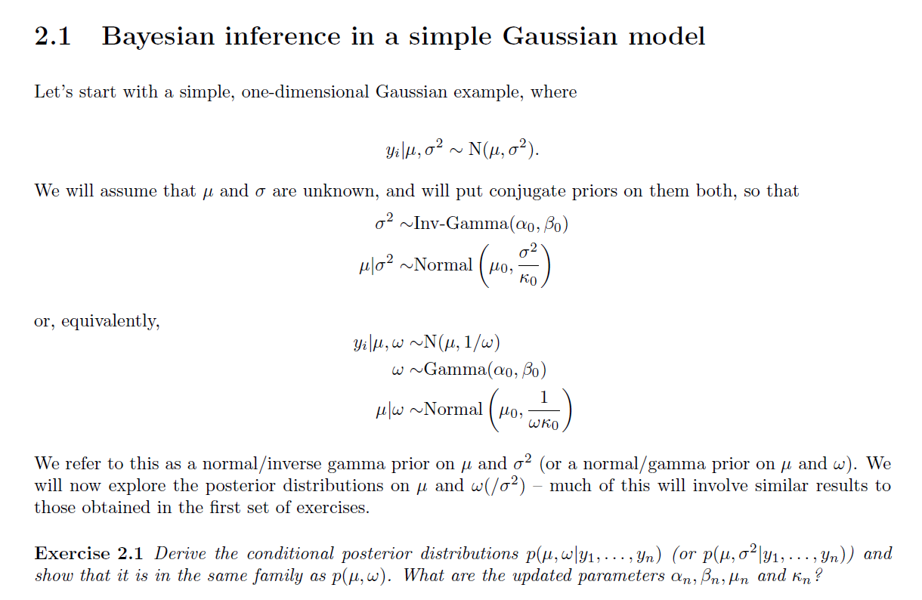

Solution

First, we need to find the likelihood:

$p\left(y_{1},y_{2},…,y_{n} | μ,ω\right)=\frac{1}{{\left(2π\right)}^{\frac{n}{2}}}ω^{\frac{n}{2}}exp\left(-\frac{ω}{2}\sum_{i=1}^{n}{{\left(y_{i}-μ\right)}^{2}}\right)=\frac{1}{{\left(2π\right)}^{\frac{n}{2}}}ω^{\frac{n}{2}}exp\left(-\frac{ω}{2}\left[n{\left(μ-\overline{y}\right)}^{2}+\sum_{i=1}^{n}{{\left(y_{i}-\overline{y}\right)}^{2}}\right]\right)$

From the question we have the prior on $μ$ and the prior on $ω$, Conjugate prior on $μ,ω$ is as following:

$$p\left(μ,ω | {μ_{0}, k_{0}, α}_{0},β_{0}\right)=N\left(μ_{0},\frac{1}{k_{0}ω}\right)*Gamma\left(ω | α_{0},β_{0}\right)=\frac{1}{\frac{Γ\left(α_{0}\right)}{{β_{0}}^{α_{0}}}{\left(\frac{2π}{k_{0}}\right)}^{\frac{1}{2}}}ω^{\frac{1}{2}}exp\left(-\frac{k_{0}ω}{2}{\left(μ-μ_{0}\right)}^{2}\right)ω^{α_{0}-1}exp\left(-ωβ_{0}\right)=\frac{1}{\frac{Γ\left(α_{0}\right)}{{β_{0}}^{α_{0}}}{\left(\frac{2π}{k_{0}}\right)}^{\frac{1}{2}}}ω^{α_{0}-\frac{1}{2}}exp\left(-\frac{ω}{2}\left[k_{0}{\left(μ-μ_{0}\right)}^{2}+2β_{0}\right]\right)$$

Posterior distribution is proportional to the product of likelihood and conjugate prior:

$p\left(μ,ω | y_{1},y_{2},…,y_{n}\right)∝p\left(μ,ω | {μ_{0}, k_{0}, α}_{0},β_{0}\right)*p\left(y_{1},y_{2},…,y_{n} | μ,ω\right)∝\frac{1}{\frac{Γ\left(α_{0}\right)}{{β_{0}}^{α_{0}}}{\left(\frac{2π}{k_{0}}\right)}^{\frac{1}{2}}}ω^{α_{0}-\frac{1}{2}}exp\left(-\frac{ω}{2}\left[k_{0}{\left(μ-μ_{0}\right)}^{2}+2β_{0}\right]\right)$ $\frac{1}{{\left(2π\right)}^{\frac{n}{2}}}ω^{\frac{n}{2}}exp\left(-\frac{ω}{2}\left[n{\left(μ-\overline{y}\right)}^{2}+\sum_{i=1}^{n}{{\left(y_{i}-\overline{y}\right)}^{2}}\right]\right)$

$$∝ω^{\frac{1}{2}}ω^{\frac{n}{2}+α_{0}-1}exp\left(-\frac{ω}{2}\left[k_{0}{\left(μ-μ_{0}\right)}^{2}+2β_{0}\right]-\frac{ω}{2}\left[n{\left(μ-\overline{y}\right)}^{2}+\sum_{i=1}^{n}{{\left(y_{i}-\overline{y}\right)}^{2}}\right]\right)$$

$$∝ω^{\frac{1}{2}}ω^{\frac{n}{2}+α_{0}-1}exp\left(-\frac{ω}{2}\left[k_{0}{\left(μ-μ_{0}\right)}^{2}+n{\left(μ-\overline{y}\right)}^{2}+\sum_{i=1}^{n}{{\left(y_{i}-\overline{y}\right)}^{2}}+2β_{0}\right]\right)$$

$k_{0}{\left(μ-μ_{0}\right)}^{2}+n{\left(μ-\overline{y}\right)}^{2}+\sum_{i=1}^{n}{{\left(y_{i}-\overline{y}\right)}^{2}}=\left(k_{0}+n\right){\left(μ-μ_{n}\right)}^{2}+\frac{k_{0}n{\left(\overline{y}-μ_{0}\right)}^{2}}{k_{0}+n}+\sum_{i=1}^{n}{{\left(y_{i}-\overline{y}\right)}^{2}}$

$where μ_{n} = \frac{k_{0}μ_{0}+n\overline{y}}{k_{0}+n}$

**

So,

$$p\left(μ,ω | y_{1},y_{2},…,y_{n}\right)∝ω^{\frac{1}{2}}exp\left(-\frac{ω}{2}\left[\left(k_{0}+n\right){\left(μ-μ_{n}\right)}^{2}\right]\right)*ω^{\frac{n}{2}+α_{0}-1}exp\left(-β_{0}ω\right)exp\left(-\frac{ω}{2}\sum_{i=1}^{n}{{\left(y_{i}-\overline{y}\right)}^{2}}\right)exp\left(-\frac{ω}{2}\frac{k_{0}n{\left(\overline{y}-μ_{0}\right)}^{2}}{k_{0}+n}\right)$$

$$∝ N (μ|μ_{n}, {((k_{n})ω)}^{-1})*Gamma(ω|α_{n}, β_{n})$$

Normal Gamma distribution, $where$



$$μ_{n}=\frac{k_{0}μ_{0}+n\overline{y}}{k_{0}+n}$$

$$k_{n}=k_{0}+n$$

$$α_{n}=α_{0}+\frac{n}{2}$$

$$β_{n} = β_{0} + \frac{1}{2}\sum_{i=1}^{n}{{\left(x_{i}-\overline{x}\right)}^{2}+} \frac{k_{0}n{\left(\overline{y}-μ_{0}\right)}^{2}}{2\left(k_{0}+n\right)}$$

Solution

$p(μ|ω, y_{1}, y_{2}, ..., y_{n}) = p(y_{1}, y_{2}, ..., y_{n}|μ,ω) p(μ|ω)$

First, we need to find $p(y_{1}, y_{2}, ..., y_{n}|μ,ω)$ which is equal to

$p\left(y_{1},y_{2},…,y_{n} | μ,ω\right)=\frac{1}{{\left(2π\right)}^{\frac{n}{2}}}ω^{\frac{n}{2}}exp\left(-\frac{ω}{2}\sum_{i=1}^{n}{{\left(x_{i}-μ\right)}^{2}}\right)=\frac{1}{{\left(2π\right)}^{\frac{n}{2}}}ω^{\frac{n}{2}}exp\left(-\frac{ω}{2}\left[n{\left(μ-\overline{y}\right)}^{2}+\sum_{i=1}^{n}{{\left(y_{i}-\overline{y}\right)}^{2}}\right]\right)$

Next, we need to find $p(μ|ω)$ which is equal to:

$p(μ|ω) = \frac{{(ωk_{0})}^{\frac{1}{2}}}{\sqrt{2π}} exp (-\frac{k_{0}ω}{2}{\left(μ-μ_{0}\right)}^{2})$

So,

$$p(μ|ω, y_{1}, y_{2}, …, y_{n}) = \frac{1}{{\left(2π\right)}^{\frac{n}{2}}}ω^{\frac{n}{2}}exp\left(-\frac{ω}{2}\left[n{\left(μ-\overline{y}\right)}^{2}+\sum_{i=1}^{n}{{\left(y_{i}-\overline{y}\right)}^{2}}\right]\right) \frac{{\left(ωk_{0}\right)}^{\frac{1}{2}}}{\sqrt{2π}} exp (-\frac{k_{0}ω}{2}{\left(μ-μ_{0}\right)}^{2}) ∝ exp (-\frac{ω}{2}[n{\left(μ-\overline{y}\right)}^{2}-k_{0}{\left(μ-μ_{0}\right)}^{2}]) ∝ exp (-\frac{ω}{2}[n(μ^{2}-2μ\overline{y}+{\overline{y}}^{2})+k_{0}(μ^{2}-2μμ_{0}+{μ_{0}}^{2})]) ∝ exp (-\frac{ω}{2}[(n+k_{0})μ^{2}-2μ(n\overline{y}+k_{0}μ_{0})] ∝ exp (\frac{-ω(n+k_{0})(μ-\frac{n\overline{y}+k_{0}y_{0}}{n+k_{0}}) }{2})$$

The above function is the kernel of normal distribution. Therefore, conditional posterior distribution of $μ$ is:

$$p(μ|ω, y_{1}, y_{2}, …, y_{n}) \sim Normal (\frac{n\overline{y}+k_{0}y_{0}}{n+k_{0}}, \frac{1}{ω(n+k_{0})})$$

Reasonable interpretation on parameters ${μ_{0}, k_{0}, α}_{0},β_{0}$

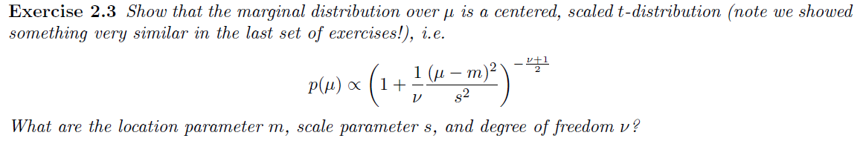

Solution

Marginal distribution over $μ$ is obtained through following:

$p(μ) = \int{p(μ,ω)dω = \int{\frac{1}{\frac{Γ\left(α_{0}\right)}{{β_{0}}^{α_{0}}}{\left(\frac{2π}{k_{0}}\right)}^{\frac{1}{2}}}ω^{α_{0}+\frac{1}{2}-1}exp\left(-\frac{ω}{2}\left[k_{0}{\left(μ-μ_{0}\right)}^{2}+2β_{0}\right]\right) dω ∝ \int{ω^{α_{0}+\frac{1}{2}-1}exp\left(-ω\left[\frac{k_{0}}{2}{\left(μ-μ_{0}\right)}^{2}+β_{0}\right]\right)dω } }}$

Under the integral is the kernel of gamma ( $α, β)$ distribution

where $α = α_{0}+\frac{1}{2} , β =\frac{k_{0}}{2}{\left(μ-μ_{0}\right)}^{2}+β_{0}$.

So,

$p(μ) ∝ \frac{Γ\left(α\right)}{β^{α}} ∝ β^{-α} = {(\frac{k_{0}}{2}{\left(μ-μ_{0}\right)}^{2}+β_{0})}^{-\frac{(2α_{0}+1)}{2}} = {(1+\frac{1}{2α_{0}}\frac{α_{0}k_{0}{\left(μ-μ_{0}\right)}^{2}}{β_{0}})}^{-\frac{(2α_{0}+1)}{2}}$

a scaled t distribution where $m =μ_{0} , v = 2α_{0}, s^{2}=\frac{β_{0}}{α_{0}k_{0}}$



Solution

$$p\left(μ\right)=\int{p\left(μ,ω\right)dω=}\int{ω^{\frac{1}{2}}exp\left(-\frac{ω}{2}\left[k_{n}{\left(μ-μ_{n}\right)}^{2}\right]\right)*ω^{α_{n}-1}exp\left(-β_{n}ω\right)}dω = \int{ω^{α_{n}+\frac{1}{2}-1}exp(-ω[}β_{n}+\frac{k_{n}{\left(μ-μ_{n}\right)}^{2}}{2}])dω$$

Under the integral is the kernel of gamma ( $α, β)$ distribution

where $α = α_{n}+\frac{1}{2} , β =\frac{k_{n}}{2}{\left(μ-μ_{n}\right)}^{2}+β_{n}$.

So,

$p\left(μ\right)∝\frac{Γ\left(α\right)}{β^{α}}∝β^{-α}={\left(\frac{k_{n}}{2}{\left(μ-μ_{n}\right)}^{2}+β_{n}\right)}^{-\frac{\left(2α_{n}+1\right)}{2}}={\left(1+\frac{1}{2α_{n}}\frac{α_{n}k_{n}{\left(μ-μ_{n}\right)}^{2}}{β_{n}}\right)}^{-\frac{\left(2α_{n}+1\right)}{2}}$

Scaled t distribution with $m =μ_{n} , v = 2α_{n}, s^{2}=\frac{β_{n}}{α_{n}k_{n}}$



Solution

It is better to first solve the exercise 2.6 and then solve this exercise.

$$p (y_{n+1},y_{n+2},…,y_{n+m}|y_{1},y_{2},…,y_{n}) = \frac{p(Y_{new} \& Y_{old})}{p(Y_{old})}$$

from the exercise 2.6 we found the marginal distribution over Y. So, we can write



$$\frac{p(Y_{new} \& Y_{old})}{p(Y_{old})} = \frac{\frac{Z_{n+m}}{Z_{0} {(2π)}^{\frac{n+m}{2}}} }{\frac{Z_{n}}{Z_{0} {(2π)}^{\frac{n}{2}}} } =\frac{Z_{n+m}}{Z_{n}{(2π)}^{\frac{m}{2}}} = = \frac{Γ\left(α_{n+m}\right)}{Γ\left(α_{n}\right)}\frac{{β_{n}}^{α_{n}}}{{β_{n+m}}^{α_{n+m}}}{(\frac{k_{n}}{k_{n+m}})}^{\frac{1}{2}}{(2π)}^{\frac{-m}{2}}$$

Solution:

$$p(μ,ω|Y) = \frac{p(Y,μ,ω)}{p(Y)} → p(Y) = \frac{p(Y,μ,ω)}{p(μ,ω|Y)}$$

$$p(Y,μ,ω) = NG(\left(μ,ω | {μ_{0}, k_{0}, α}_{0},β_{0}\right) \prod_{i=1}^{n}{N(y_{i}|μ,ω)} = \frac{1}{Z_{0}}ω^{α_{0}-\frac{1}{2}}exp\left(-\frac{ω}{2}\left[k_{0}{\left(μ-μ_{0}\right)}^{2}+2β_{0}\right]\right) * \frac{1}{{\left(2π\right)}^{\frac{n}{2}}}ω^{\frac{n}{2}}exp\left(-\frac{ω}{2}\sum_{i=1}^{n}{{\left(x_{i}-μ\right)}^{2}}\right) = \frac{ω^{α_{n}-\frac{1}{2}}}{Z_{0} {(2π)}^{\frac{n}{2}}} exp \{-\frac{ω}{2}k_{0}{(μ-μ_{n})}^{2}+2β_{n}\}$$

where $Z_{0} = \frac{Γ\left(α_{0}\right)}{{β_{0}}^{α_{0}}}{\left(\frac{2π}{k_{0}}\right)}^{\frac{1}{2}}$

If we divide the above equation by the posterior distribution:

$$p(y) = \frac{\frac{ω^{α_{n}-\frac{1}{2}}}{Z_{0} {(2π)}^{\frac{n}{2}}} exp \{-\frac{ω}{2}{(k}_{0}{(μ-μ_{n})}^{2}+2β_{n})\}}{\frac{1}{Z_{n}} exp\{\frac{-ω}{2}{(k}_{0}{(μ-μ_{n})}^{2}+2β_{n})\}} = \frac{Z_{n}}{Z_{0} {(2π)}^{\frac{n}{2}}} = \frac{Γ\left(α_{n}\right)}{Γ\left(α_{0}\right)}\frac{{β_{0}}^{α_{0}}}{{β_{n}}^{α_{n}}}{(\frac{k_{0}}{k_{n}})}^{\frac{1}{2}}{(2π)}^{\frac{-n}{2}}$$

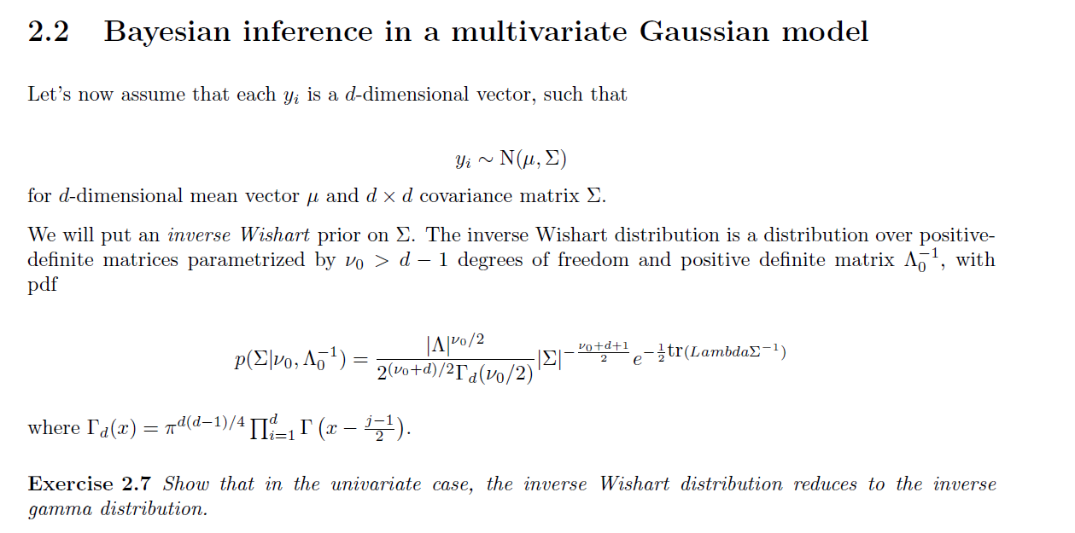

Solution:

Probability density function of the inverse Wishart is as follows:

$$\frac{{|Λ|}^{\frac{ν_{0}}{2}}}{2^{(ν_{0}*d)/2}Γ_{d}(ν_{0}/2)} {|Σ|}^{-\frac{ν_{0}+d+1}{2}}e^{-\frac{1}{2}tr(ΛΣ^{-1})}$$

Where $Λ$ and $Σ$ are d*d positive definite matrices, and $Γ_{d}(.)$ is the multivariate gamma function.

With d=1, $α =\frac{ν_{0}}{2} , β = \frac{Λ}{2}$, the probability density function of inverse Wishart becomes:

$\frac{{\left|\frac{Λ}{2}\right|}^{\frac{ν_{0}}{2}}}{Γ_{1}\left(ν_{0}/2\right)} {\left|Σ\right|}^{-\frac{ν_{0}}{2}-1}e^{-\frac{1}{2}\left(ΛΣ^{-1}\right)} = \frac{β^{α}}{Γ_{1}\left(α\right)}{\left|Σ\right|}^{-α-1}e^{-\frac{β}{Σ}}$ = Inverse Gamma ($Σ; α,β)$

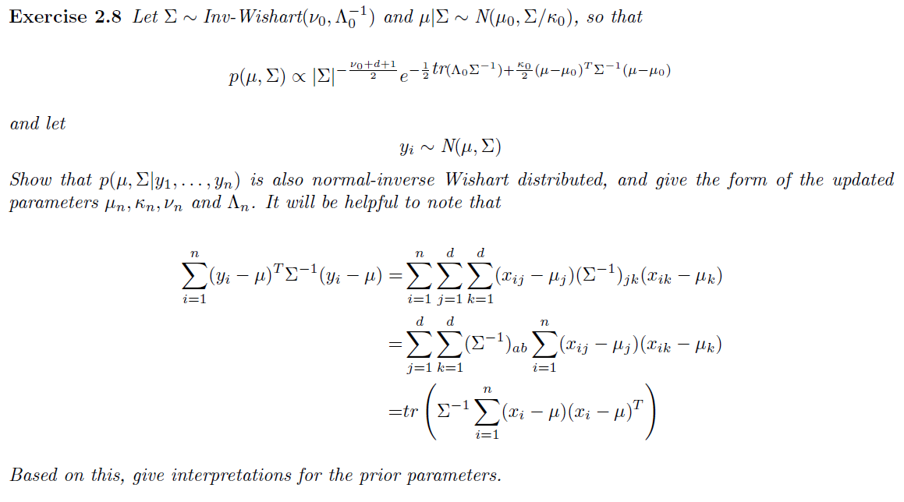

Solution

Posterior distribution can be written as following:

$p\left(μ,Σ | y_{1},y_{2},…,y_{n}\right)∝p\left(μ,Σ | {μ_{0}, k_{0}, α}_{0},β_{0}\right)*p\left(y_{1},y_{2},…,y_{n} | μ,Σ\right)$

From the question we have:

$p\left(μ,Σ | {μ_{0}, k_{0}, α}_{0},β_{0}\right) ∝ {|Σ|}^{-\frac{ν_{0}+d+1}{2}}e^{-\frac{1}{2}tr(Λ_{0}Σ^{-1})-\frac{k_{0}}{2}{(μ-μ_{0})}^{T}Σ^{-1}(μ-μ_{0})}$

$$p\left(y_{1},y_{2},…,y_{n} | μ,Σ\right) = {\left|Σ\right|}^{-\frac{n}{2}}exp(-\frac{1}{2}\sum_{i=1}^{n}{{\left(y_{i}-μ\right)}^{T}Σ^{-1}(y_{i}-μ))}$$

So,

$p\left(μ,Σ | y_{1},y_{2},…,y_{n}\right)$ =

$${|Σ|}^{-\frac{ν_{0}+d+1}{2}}exp((-\frac{1}{2}tr(Λ_{0}Σ^{-1})-\frac{k_{0}}{2}{(μ-μ_{0})}^{T}Σ^{-1}(μ-μ_{0}))*{\left|Σ\right|}^{-\frac{n}{2}}exp(-\frac{1}{2}\sum_{i=1}^{n}{{\left(y_{i}-μ\right)}^{T}Σ^{-1}(y_{i}-μ))} = {|Σ|}^{-\frac{ν_{0}+n+d+1}{2}}exp((-\frac{1}{2}tr(Λ_{0}Σ^{-1})-tr(Σ^{-1}\frac{k_{0}}{2}{(μ-μ_{0})}^{T}(μ-μ_{0})) - \frac{1}{2}tr(Σ^{-1}\sum_{i=1}^{n}{{\left(y_{i}-μ\right)}^{T}\left(y_{i}-μ\right))} = {|Σ|}^{-\frac{ν_{0}+n+d+1}{2}}exp((-\frac{1}{2}tr(Λ_{0}+k_{0}{(μ-μ_{0})}^{T}(μ-μ_{0})+\sum_{i=1}^{n}{{\left(y_{i}-μ\right)}^{T}\left(y_{i}-μ\right)Σ^{-1})} = {|Σ|}^{-\frac{ν_{0}+n+d+1}{2}}exp((-\frac{1}{2}tr(Λ_{0}+k_{0}{(μ-μ_{0})}^{T}(μ-μ_{0})+\sum_{i=1}^{n}{{\left(y_{i}-\overline{y}\right)}^{T}\left(y_{i}-\overline{y}\right)} +n {\left(μ-\overline{y}\right)}^{T}\left(μ-\overline{y}\right)Σ^{-1}) = {|Σ|}^{-\frac{ν_{0}+n+d+1}{2}}exp((-\frac{1}{2}tr(Λ_{0} +S + (k_{0}+n)μ^{2}-2μ(k_{0}μ_{0}+n\overline{y}) +k_{0}{μ_{0}}^{2}+ n{\overline{y}}^{2})Σ^{-1}) ∝ {|Σ|}^{-\frac{ν_{0}+n+d+1}{2}}exp((-\frac{1}{2}tr(Λ_{0} +S + {(μ-\frac{k_{0}μ_{0}+n\overline{y}}{k_{0}+n})}^{T}(μ-\frac{k_{0}μ_{0}+n\overline{y}}{k_{0}+n})+ \frac{k_{0}n}{k_{0}+n}{ (\overline{y} - μ_{0})}^{T}(\overline{y} - μ_{0}))Σ^{-1}) = {|Σ|}^{-\frac{ν_{0}+n+d+1}{2}}exp((-\frac{1}{2}tr(Λ_{0} +S + \frac{k_{0}n}{k_{0}+n}{ (\overline{y} - μ_{0})}^{T}(\overline{y} - μ_{0}))Σ^{-1}) +{(μ-\frac{k_{0}μ_{0}+n\overline{y}}{k_{0}+n})}^{T}Σ^{-1}(μ-\frac{k_{0}μ_{0}+n\overline{y}}{k_{0}+n})$$

$k_{0}{(μ-μ_{0})}^{T}(μ-μ_{0})+\sum_{i=1}^{n}{{\left(y_{i}-μ\right)}^{T}\left(y_{i}-μ\right))} = k_{0}{(μ-μ_{0})}^{T}(μ-μ_{0})+\sum_{i=1}^{n}{{\left(y_{i}-\overline{y}\right)}^{T}\left(y_{i}-\overline{y}\right)} +n {\left(μ-\overline{y}\right)}^{T}\left(μ-\overline{y}\right))$

$S = \sum_{i=1}^{n}{{\left(y_{i}-\overline{y}\right)}^{T}\left(y_{i}-\overline{y}\right)}$

**

**

So, the posterior is normal inverse Wishart with the following updated parameters:

$$ν_{n} = ν_{0}+n$$

$$Λ_{n} = Λ_{0}+ S + \frac{k_{0}n}{k_{0}+n}{ (\overline{y} - μ_{0})}^{T}(\overline{y} - μ_{0})$$

$$k_{n} = k_{0} +n$$

$$μ_{n} = \frac{k_{0}μ_{0}+n\overline{y}}{k_{0}+n}$$

Interpretations for the prior parameter:

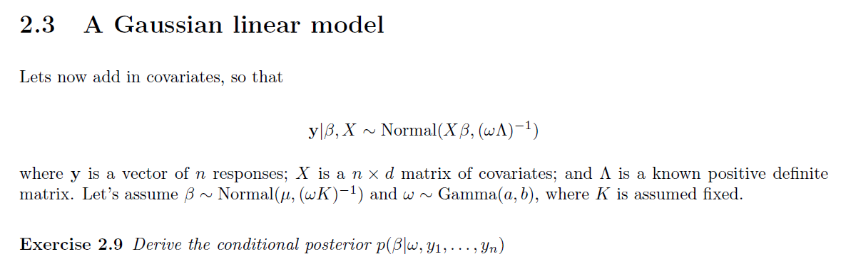

Solution

From the question we have:

$y|β, X \sim Normal (Xβ, {(ωΛ)}^{-1})$

$β\sim Normal (μ, {(ωK)}^{-1})$

$ω \sim Gamma (a,b)$

We want to find $p\left(β | ω,y_{1},y_{2},…,y_{n}\right)$

So, we can write

$$p\left(β | ω,y_{1},y_{2},…,y_{n}\right)=p\left(y_{1},y_{2},…,y_{n} | β,ω\right)*p\left(β | ω\right)=N\left(Xβ,{\left(ωΛ\right)}^{-1}\right)*N\left(μ,{\left(ωK\right)}^{-1}\right) ∝ exp(\frac{-(ωΛ){(Y-Xβ)}^{T}(Y-Xβ)}{2}) exp(\frac{-(ωK){(β-μ)}^{T}(β-μ)}{2}) ∝ exp(\frac{-(ω)[{(Λ(Y-Xβ)}^{T}(Y-Xβ))+(K{(β-μ)}^{T}(β-μ))]}{2}) ∝ exp(\frac{-(ω)[{((Y)}^{T}ΛY-2{(Y)}^{T}ΛXβ+{(Xβ)}^{T}Xβ + β^{T}Kβ - 2 ]}{2}) ∝ exp (\frac{-(ω(K+X^{T}ΛX)) (β - \frac{X^{T}ΛY+kμ}{K+X^{T}ΛX})}{2}$$

So, this distribution is normal with mean of $\frac{X^{T}ΛY+kμ}{K+X^{T}ΛX}$ and variance of ${(ω(K+X^{T}ΛX))}^{-1}$.

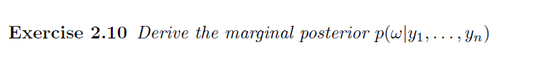

Solution:

$$p(ω|Y) = \int{p(β,ω|y) dβ}$$

$$**p\left(β,ω | Y\right)=p\left(β,ω\right)*p\left(Y | β,ω\right)=p\left(β | ω\right)p\left(ω\right)p\left(Y | β,ω\right)$$

$$p(ω|Y) = \int{p\left(β | ω\right)p\left(ω\right)p\left(Y | β,ω\right)dβ=p\left(ω\right)\int{p\left(β | ω\right) p\left(Y | β,ω\right)dβ = }}ω^{a-1}exp(-bω) \int{{\left(\frac{ωK}{2π}\right)}^{\frac{1}{2}}exp\left(\frac{-\left(ω\right){\left(β-μ\right)}^{T}K\left(β-μ\right)}{2}\right)*{\left(\frac{ωΛ}{2π}\right)}^{\frac{n}{2}}exp\left(\frac{-\left(ω\right){\left(Y-Xβ\right)}^{T}Λ\left(Y-Xβ\right)}{2}\right)}dβ= ω^{a+\frac{1}{2} +\frac{n}{2}-1}exp(-bω) \int{exp\left(\frac{-(ω){[(β-μ)}^{T}K(β-μ)+{\left(Y-Xβ\right)}^{T}Λ(Y-Xβ)]}{2}\right)dβ} = ω^{a+\frac{1}{2} +\frac{n}{2}-1}exp(-bω) exp (\frac{-\left(ω\right)\left[μ^{T}Kμ+Y^{T}ΛY\right]}{2}) \int{exp(\frac{-\left(ω\right)\left[β^{T}Kβ-2μ^{T}Kβ-2Y^{T}ΛXβ+{\left(Xβ\right)}^{T}ΛXβ\right]}{2}}) dβ = ω^{a+\frac{1}{2} +\frac{n}{2}-1} exp (-ω[b+\frac{μ^{T}Kμ + Y^{T}ΛY}{2}]\int{exp\frac{-(ω)(k+X^{T}ΛX)[{(β - \frac{μk +Y^{T}ΛX}{K+X^{T}ΛX})}^{2} - {(\frac{μk +Y^{T}ΛX}{K+X^{T}ΛX})}^{2}]}{2 }}dβ$$

$μ_{n} = \frac{μk +Y^{T}ΛX}{K+X^{T}ΛX}$

$$ω^{a+\frac{n}{2}-1}exp (-(ω)[b+\frac{1}{2}(μ^{T}Kμ + Y^{T}ΛY - {μ_{n}}^{T}(k+X^{T}ΛX)μ_{n})])$$

**

A gamma distribution with the updated parameters of

$a_{n} = a+\frac{n}{2},b_{n} = b+\frac{1}{2}(μ^{T}Kμ + Y^{T}ΛY - {μ_{n}}^{T}(k+X^{T}ΛX)μ_{n})$

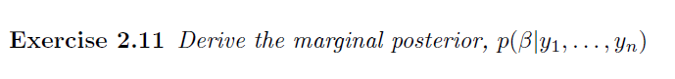

Solution:

$$p(β|Y) = \int{p(β|ω,y)*p(ω|y)dω} = \int{{(\frac{ω(K+X^{T}ΛX)}{2π})}^{\frac{1}{2}}} exp(\frac{- {(β - μ_{n})}^{T}ω(K+X^{T}ΛX)(β - μ_{n})}{2}) \frac{{{(b}_{n})}^{a_{n}}}{Γ\left(α_{n}\right)}ω^{ a_{n}-1}exp(-ω (b_{n})) dω= {(\frac{(K+X^{T}ΛX)}{2π})}^{\frac{1}{2}} \frac{{{(b}_{n})}^{a_{n}}}{Γ\left(α_{n}\right)} \int{ω^{ a_{n}+\frac{1}{2}-1}exp(-ω[}b_{n}+\frac{1}{2} ({(β - μ_{n})}^{T}(K+X^{T}ΛX)(β - μ_{n}))] dω$$

Kernel of Gamma Distribution

$= {(\frac{(K+X^{T}ΛX)}{2π})}^{\frac{1}{2}} \frac{{{(b}_{n})}^{a_{n}}}{Γ\left(α_{n}\right)} \frac{Γ(a_{n}+\frac{1}{2})}{{[b_{n}+\frac{1}{2} ({(β - μ_{n})}^{T}(K+X^{T}ΛX)(β - μ_{n}))]}^{a_{n}+\frac{1}{2}}} ={(\frac{(K+X^{T}ΛX)}{2π})}^{\frac{1}{2}} \frac{{{(b}_{n})}^{a_{n}}Γ(a_{n}+\frac{1}{2})}{Γ\left(α_{n}\right)} {[b_{n}+\frac{1}{2} ({(β - μ_{n})}^{T}(K+X^{T}ΛX)(β - μ_{n}))] }^{-(\frac{2a_{n}+1}{2})}$ t distribution with 2 $a_{n}$ degrees of freedom.

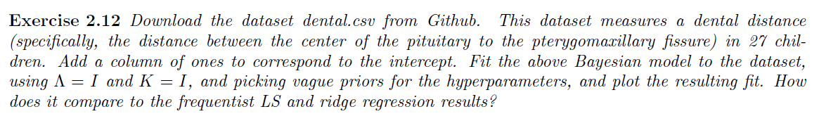

R Code is on GitHub.

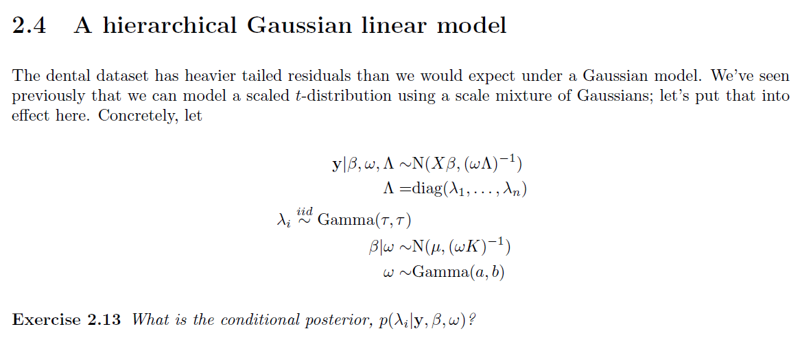

Solution:

$$Λ = diag (λ_{1}, ..., λ_{n}) , λ\sim Gamma(τ,τ)$$

$$p(Λ |ω,β, y) ∝ p(y|ω,β,Λ ) p (ω, β, Λ ) ∝ p(y|ω,β,Λ ) p(Λ ) p(ω,β )$$

$Λ$* is independent of $ω and β$.

$$∝ {λ_{i}}^{\frac{1}{2}}exp (\frac{-ωλ_{i}(y_{i}-x_{i}β)}{2}) {λ_{i}}^{τ-1}exp(-τλ_{i}) ∝ {λ_{i}}^{τ+\frac{1}{2}-1}exp((\frac{-ω(y_{i}-x_{i}β)}{2}-τ)λ_{i})$$

So, Gamma( $τ+\frac{1}{2}$, $\frac{ω{(y_{i}-x_{i}β)}^{2}}{2}+τ$).



R code is on the GitHub.

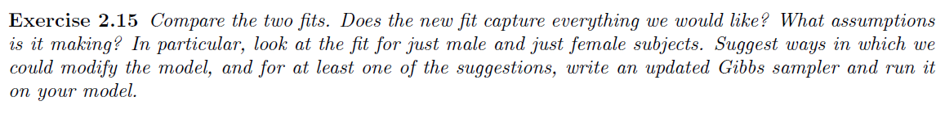

Solution

No, comparing to the linear regression, we can say that the new fit does not capture everything we would like to capture.

How to modify the model?